Overview
This guide was written by Nathan Childress, Ph.D., DABR. Although it is not officially supported, email questions can be sent to nathanchildress@doselab.com. They may be answered depending on the number of DoseLab Pro licenses purchased by the physicist asking the questions =).
It may be helpful to have your IT department install Ghostscript and the FTP server. You may already have an eligible FTP server installed on your network – ask your IT deparment.
The HotScript will do the following:
- Make a PS file of the plan’s text output.
- Prompt the user to capture screenshots and save them as PS files.
- Run Ghostscript to bundle all PS files into one PDF file.
- (Optional) FTP the PDF file to a remote server.
- Delete all PS files, and the PDF file if requested.
This ZIP file contains the following files:
- “Installing the Pinnacle PDF HotScript.doc” – Instructions for setup and configuration of the PDF HotScript for dosimetrists, physicists, or IT personnel.
- “Using the Pinnacle HotScript to Create PDFs.doc” – Instructions for clinical usage of the hotscript for dosimetrists and physicists.
- “PDFPrint.Script” – Pinnacle HotScript to be copied to the /usr/local/adacnew/PinnacleSiteData/Scripts directory on the Pinnacle server. It does not need to be edited, but can be edited to alter functionality.
- “FTPPDF” – Unix script file to be copied to the /usr/local/adacnew/PinnacleSiteData/Scripts directory. It must be edited to include your FTP server IP address, username, and password to enable automatic PDF transfer.

Install Ghostscript on each Pinnacle workstation
Every Pinnacle workstation must have Ghostscript installed. To check if Ghostscript is installed, open a terminal window and type “gs”.
If Ghostscript is not installed, or if the version number is not at least 7.0, please download and install Ghostscript from http://www.sunfreeware.com/.
- Select your system on the right hand side (SunBlade 2000 and 2500 boxes are generally SPARC / Solaris 8, and the newer 810 boxes are generally x86 / Solaris 10).
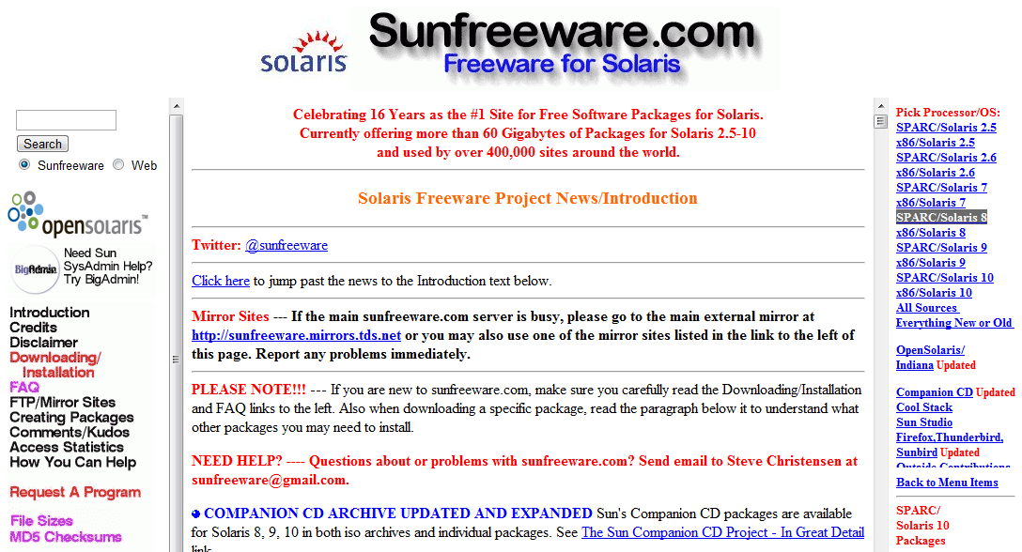
- Choose the latest version of Ghostscript from the list of software that appears on the right hand side of the page.
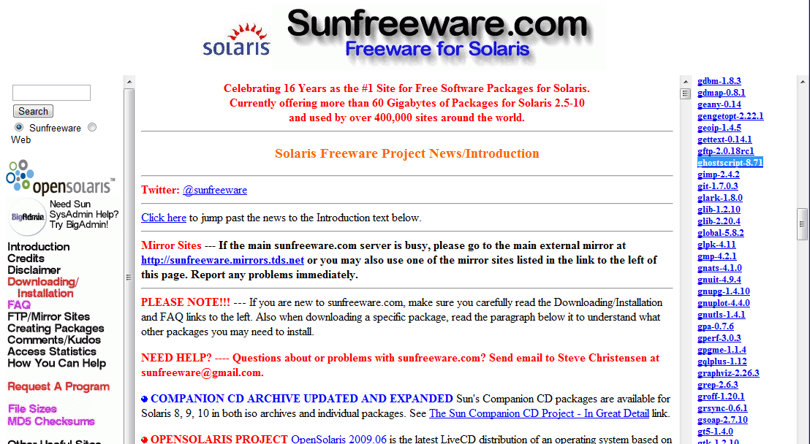
- Download the file.
- Visit http://www.sunfreeware.com/ghostscript.html for Ghostscript installation instructions.
- Repeat for each server and workstation that does not have Ghostscript 6.0 or higher installed.

Installing an FTP server
The last part of the script will FTP the PDF file to an FTP server. This allows physicists or IT to set up an FTP server on a workstation or server that has access to a share drive used to import PDF files to your record and verify system.
Ask your IT department if there is already an FTP server that a user can be added to for PDF uploading.
Note: Install the FTP server on a computer that is always on, like the DICOM image receiver of your record and verify system.
To install an FTP server:
- Download FileZilla Server from http://filezilla-project.org/download.php?type=server
- Install FileZilla Server.
- Connect to the Administration interface by clicking OK when you see this window:
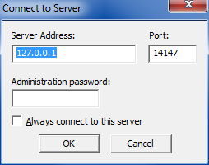
- If you do not see this window, double click the FileZilla icon in your system tray.
- In the main interface, select Edit|Users from the main menu.
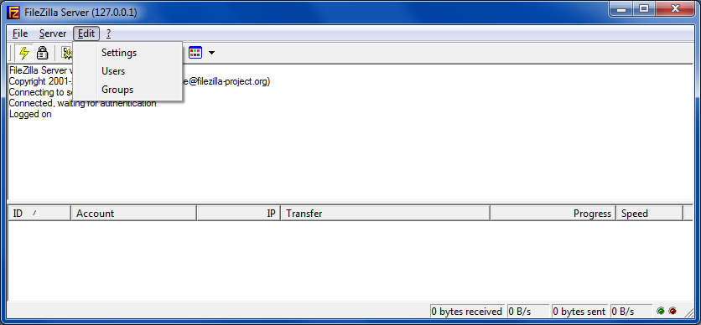
- Click the Add button in the Users section and add a user named “pdf”.
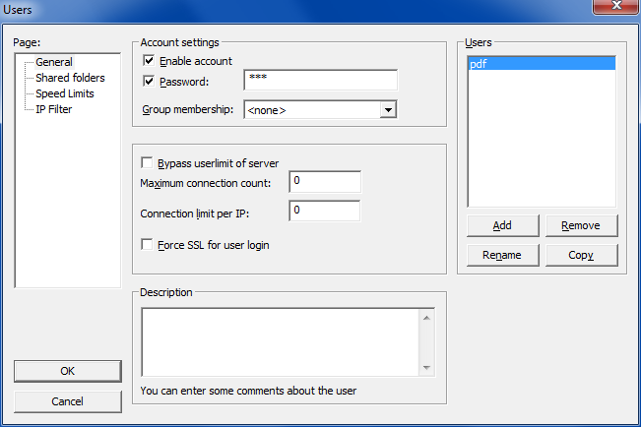
- Click the password box and type in a password of “pdf”.
- Click the “Shared folder” tab.
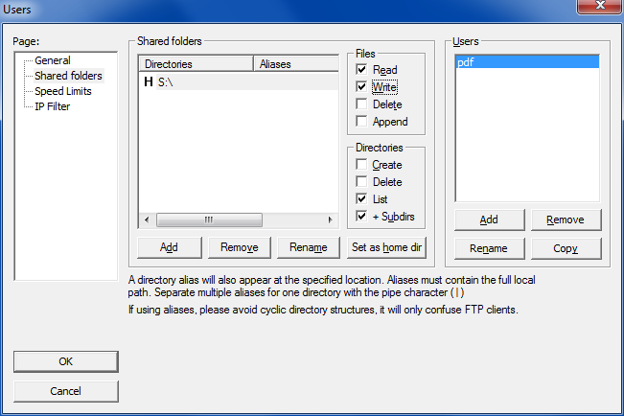
- Add the directory you would like to save PDF files to.
- Check the “Write” box under “Files” to make sure the pdf user has permission to upload files.
- Click OK.

Copying files to the Pinnacle server
Before copying the files, you will need to edit FTPPDF in a text editor (like Notepad). You must change the username and password to match the FTP server username and password that is set up at your clinic. In addition, you must change the IP address of the FTP server from 10.0.0.1 to the IP address of your FTP server.
Note: Solaris cannot use hostnames to connect to other computers. It must use a static IP address to connect to the FTP server. Explain to your confused IT worker that Solaris was released in 1992 and hasn’t changed much since then.
- After editing the file, copy both the “PDFPrint.Script” and “FTPPDF” files to the /usr/local/adacnew/PinnacleSiteData/Scripts directory on the Pinnacle server.
- You must change permissions of the “FTPPDF” file to be executable. This is usually a built-in feature of FTP clients, or you can use the Terminal program on a Pinnacle workstation and type “chmod 777 FTPPDF” after changing to the Scripts directory.
- Open Pinnacle and add the “PDFPrint.Script” script to the HotScript list. This only needs to be done once for each Pinnacle server, as the list of scripts is saved on the server.
Note: If a script fails to execute with no errors, it may have the wrong end-of-line (EOL) indicators. You can use an advanced text editing program like NotePad++ to change this (Edit | EOL Conversion | Unix format), or a simple program like NotePad to save the file without any formatting changes. The only wrong answer is using WordPad, which may convert the Unix EOLs to Windows EOLs and make the file unreadable by Pinnacle. See earlier explanation of Solaris and when it was released.

Running and testing the script
See the “Using the Pinnacle HotScript to Create PDFs.doc” file for instructions on using the script. Don’t worry if you haven’t installed an FTP server – the script will still work as-is. Just don’t delete the PDF file when asked, and manually transfer the file to your workstation.

Using the script without Ghostscript installed
For users that do not have Ghostscript installed, a modified version of the files can be found in the “No Ghostscript required (no PDF conversion)”. Copying these files to Pinncle will still allow you to generate a series of PS files, but it will FTP the PS files and not convert them to a PDF.
This means that Ghostscript does not have to be installed or upgraded on Pinnacle, but another program (like Ghostscript or Adobe Acrobat) must be installed on the Windows machine the files are transferred to in order to make the final PDF file.

Using the script without an FTP server
After installing and using the script version that you prefer (PDF files with Ghostscript installed on every Pinnacle workstation, or the PS version that does not use Ghostscript), download this file to facilitate automatic file transfers from Pinnacle to a local workstation:
http://www.medphysfiles.com/index.php?name=Downloads&file=details&id=50

